FARM MANAGEMENT SYSTEM

Team ID : SWTID-2026-6623
Team Size : 5
Team Leader : PRAVEENKUMAR . P
Team member : POOVARASAN . B
Team member : RAHUL . L
Team member : RUBESHKUMAR . D
Team member : SABARINATHAN . A

ABSTRACT

The Farm Management System (FMS) is a Salesforce-based application designed to digitize and streamline agricultural operations. It manages data related to farms, crops, farmers, and buyers while providing real-time insights through reports and dashboards. The system helps farmers and managers monitor agricultural activities efficiently and make informed decisions.

S.NO | CONTENTS
1 | INTRODUCTION
2 | IDEATION PHASE
3 | REQUIREMENT ANALYSIS PHASE
4 | PROJECT DESIGN PHASE
5 | PROJECT PLANNING AND SCHEDULING
6 | PROJECT DEVELOPMENT PHASE
7 | FUNCTIONAL  AND PERFOMANCE TESTING

1.INTRODUCTION

The Farm Management System (FMS) is a Salesforce-based application designed to digitize and streamline agricultural operations. It manages data related to farms, crops, farmers, and buyers while providing real-time insights through reports and dashboards. The system helps farmers and managers monitor agricultural activities efficiently and make informed decisions.

2. IDENTATION PHASE

The main purpose of this project is to:

- Digitize agricultural data management
- Improve data accuracy and accessibility
- Automate record handling
- Enable real-time monitoring
- Support data-driven farming decisions
- Enhance productivity and transparency

3. Empathy Map Canvas
Target Users
- Farmers
- Farm Managers
- Buyers
- System Administrators
Empathy Analysis
- Think & Feel: Need accurate and timely farm data
- Hear: Feedback from agricultural officers
- See: Registers, paper files, spreadsheets
- Say & Do: Enter records manually
- Pain: Data loss, errors, delays
- Gain: Automation, fast reporting

3.1 Brainstorming
Brainstormed Ideas
- Manual farm records
- Excel-based management
- Web-based system
- Mobile farm app
- Salesforce-based FMS
Selected Idea
Salesforce-based Farm Management System.

3.2 Solution Requirements
Functional Requirements

FR No | Requirement
FR-1 | User Authentication
FR-2 | Farm, Crop, Farmer, Buyer Management
FR-3 | Data Entry and Validation
FR-4 | Relationship Mapping
FR-5 | Report Generation
FR-6 | Dashboard Visualization
FR-7 | User Role Management

Non-Functional Requirements

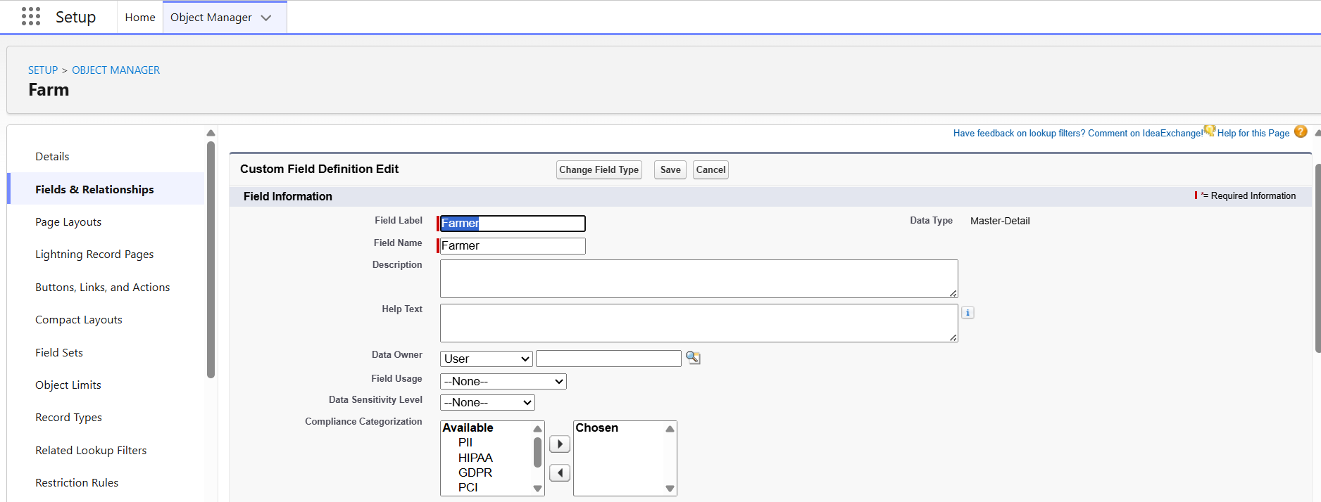

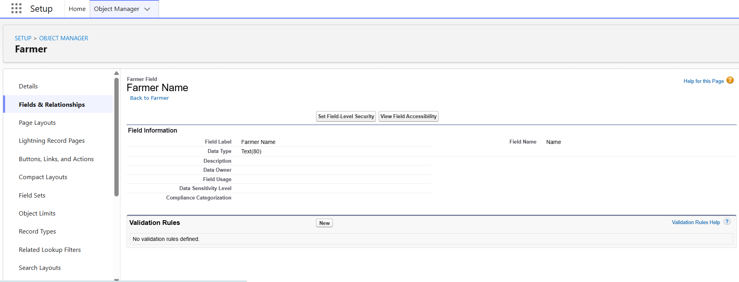

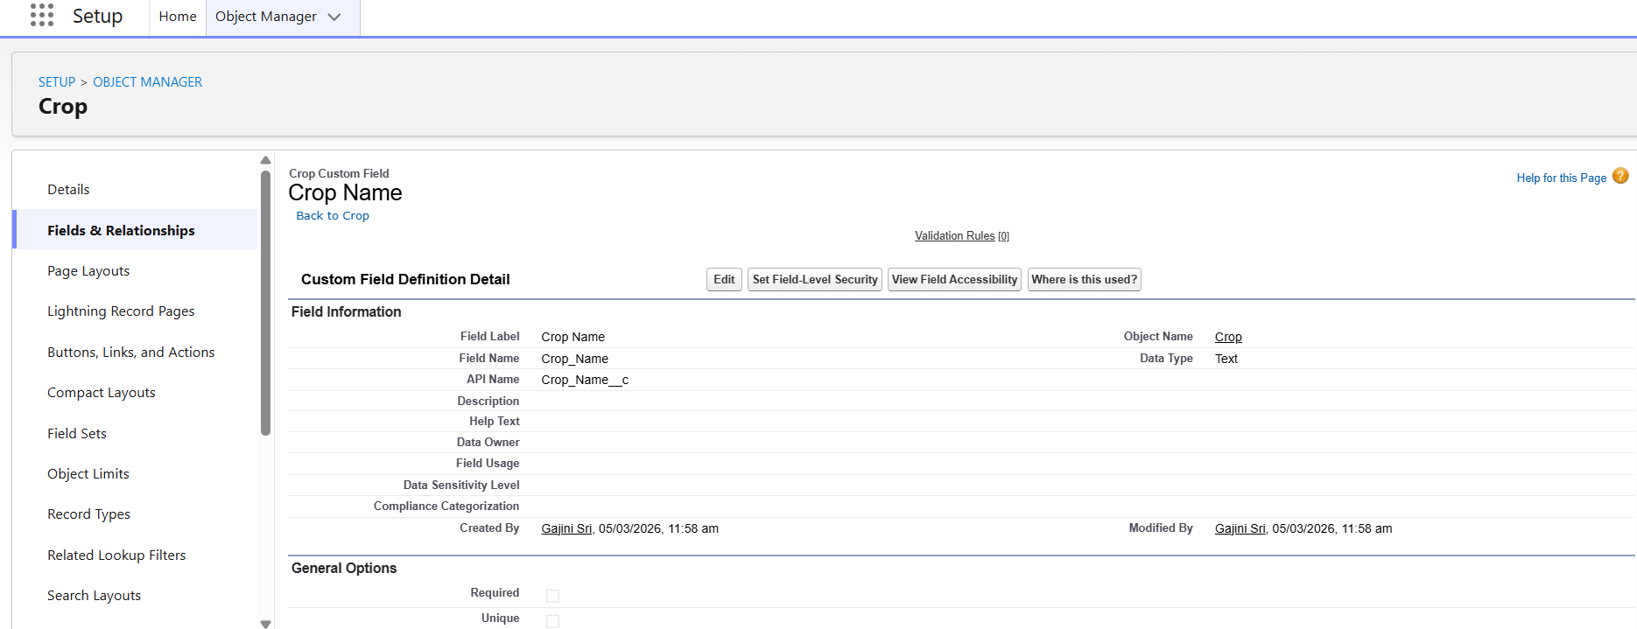

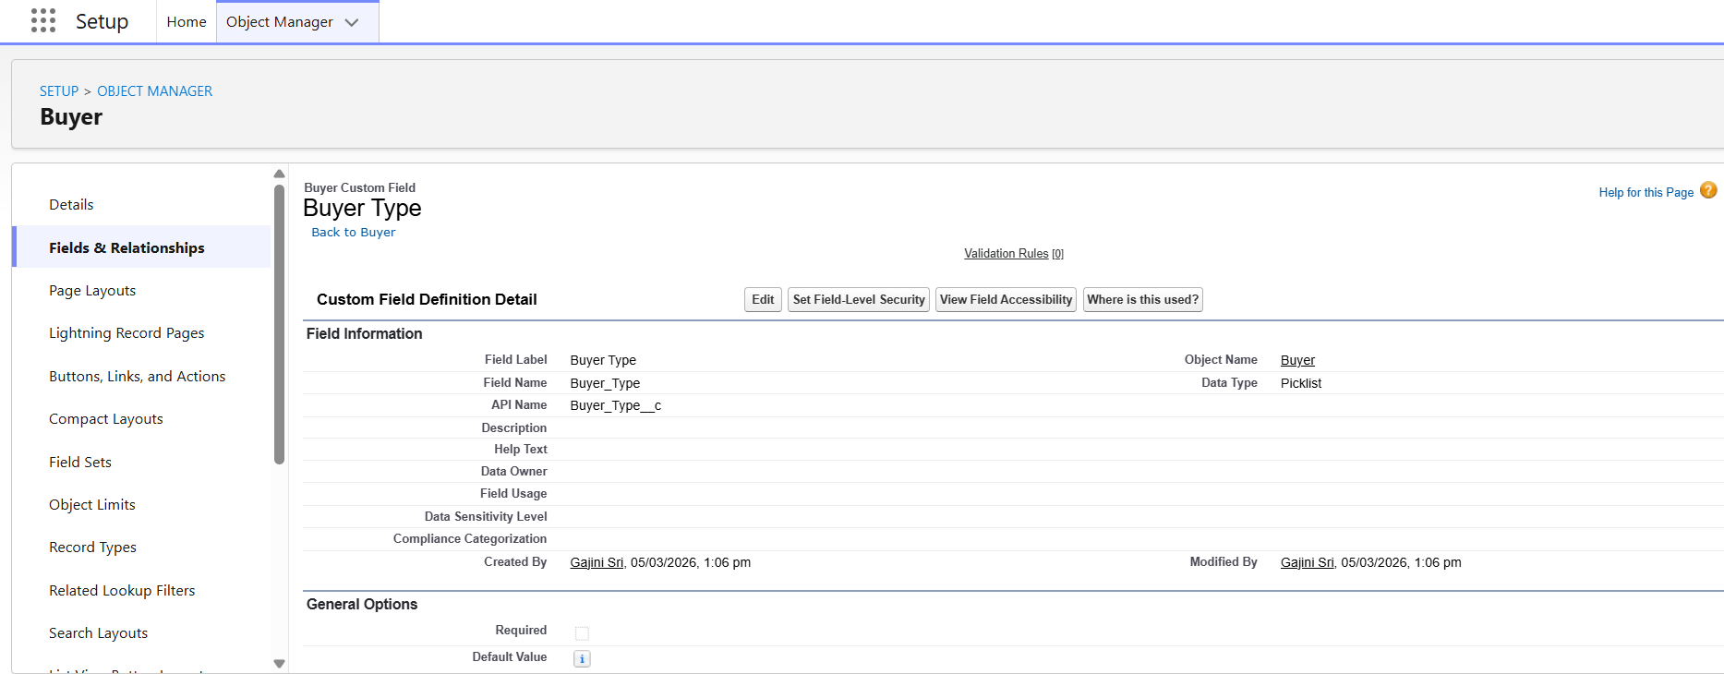

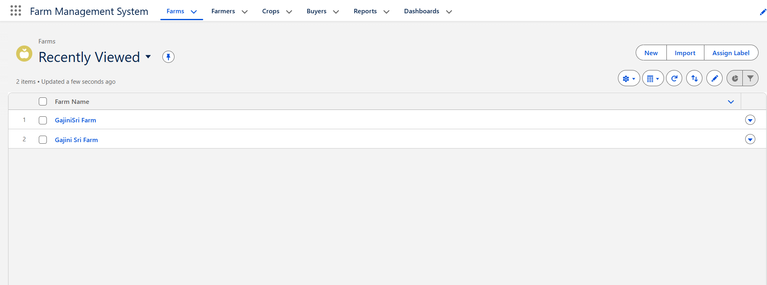

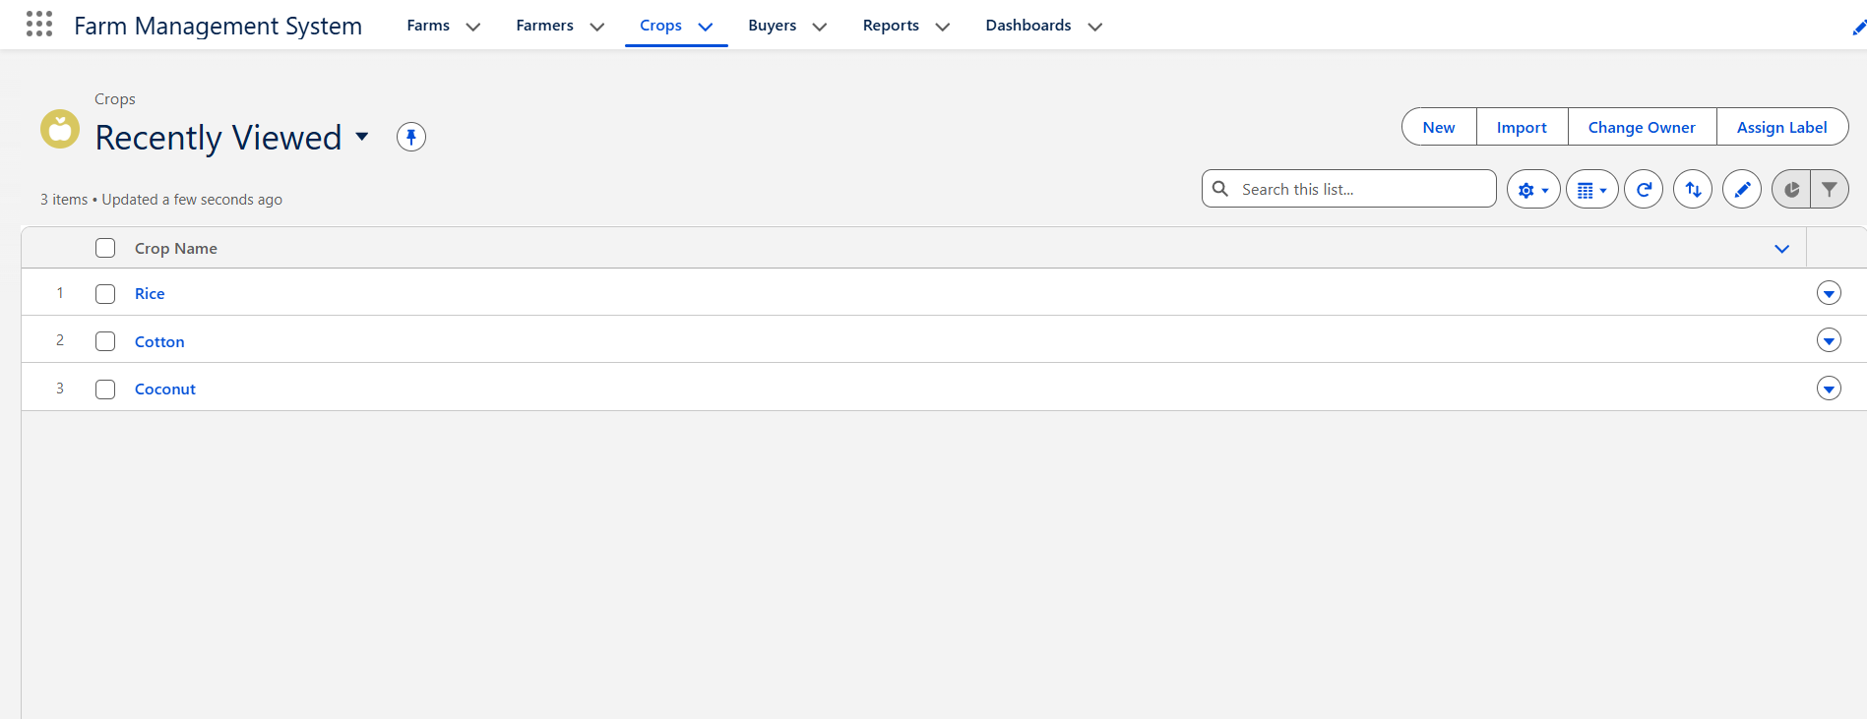

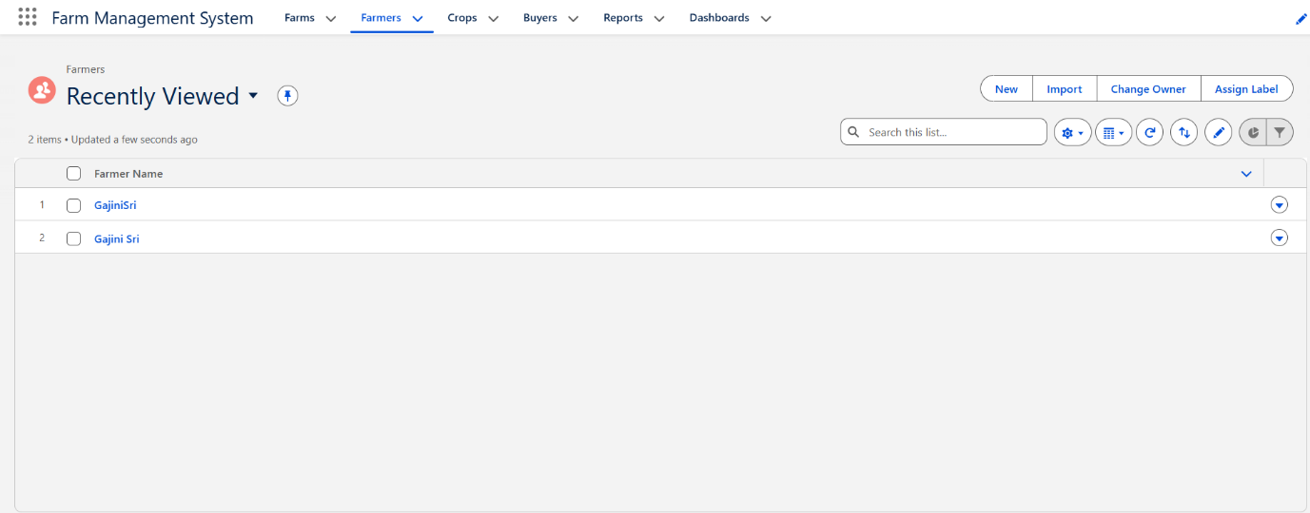

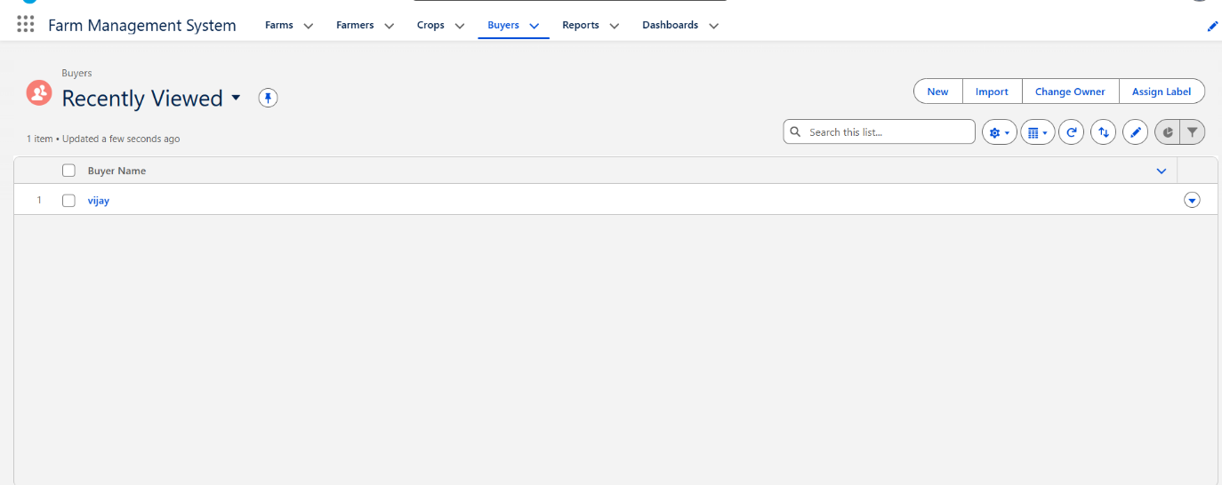

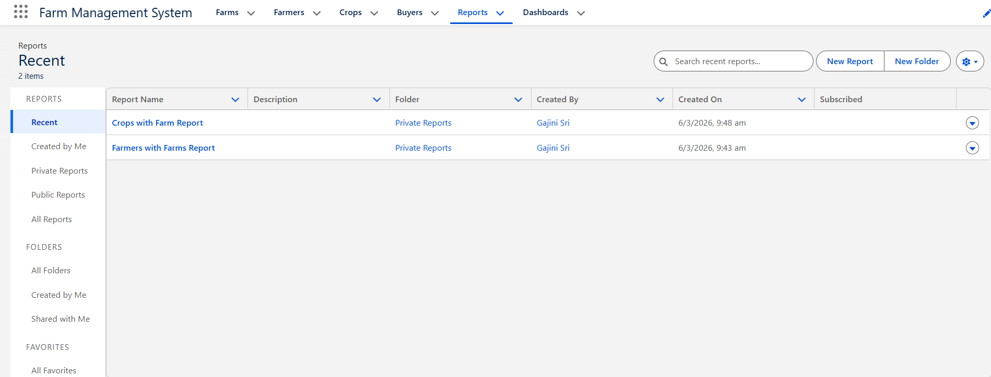

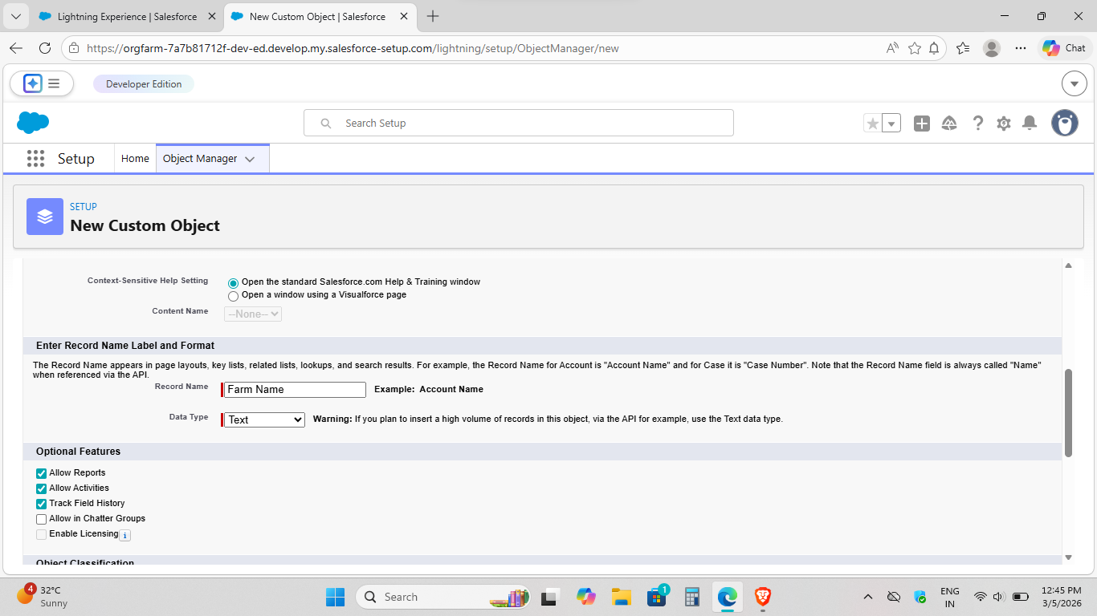



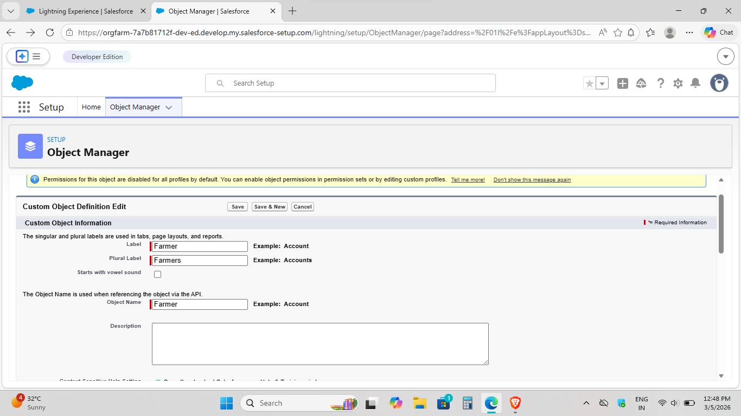

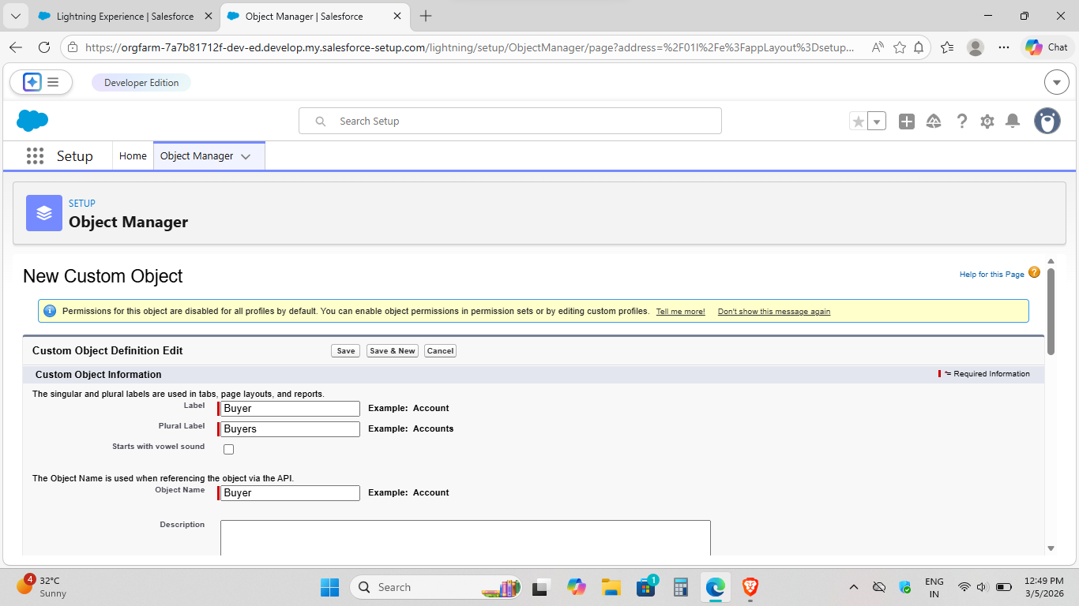

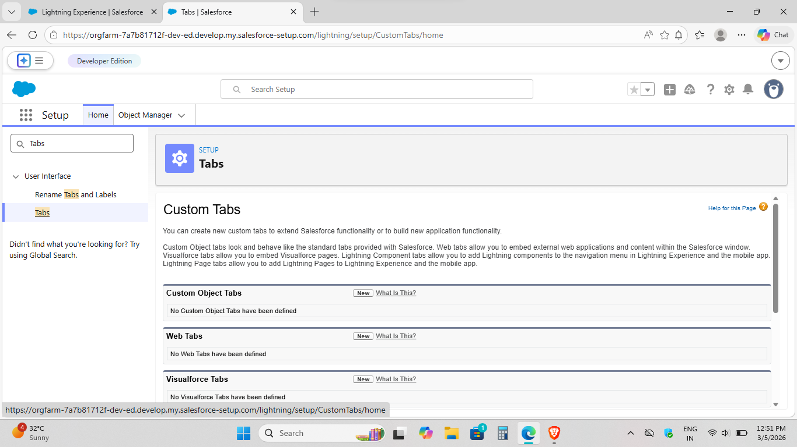

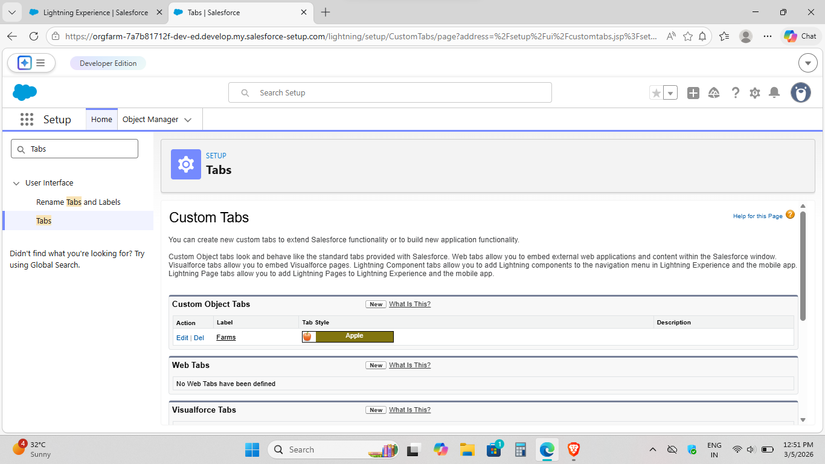

4. REQUIREMENT ANALYSIS PHASE
4.1 Problem–Solution Fit
The FMS replaces manual farming records with automated data management. Cloud storage prevents data loss, dashboards improve analysis, and real-time reports eliminate delays. This ensures accurate and timely agricultural insights.
4.2 Solution Architecture
Architecture Layers
- Presentation Layer – Salesforce Lightning UI
- Application Layer – Validation Rules, Relationships
- Data Layer – Custom Objects
- Analytics Layer – Reports and Dashboards

5. PROJECT PLANNING & SCHEDULING
5.1 Project Planning
- Created Salesforce Developer Org
- Developed custom objects
- Configured tabs and Lightning App
- Created fields and relationships
- Designed profiles and roles
- Created users and sharing rules
- Developed reports and dashboards
- Conducted testing and reviews

Product Backlog, Sprint Schedule, and Estimation
Use the below template to create product backlog and sprint schedule

6. Project Development Phase

Project Description:

The Farm Management System (FMS) in Salesforce is a comprehensive solution designed to digitize and streamline agricultural operations. This application empowers farmers, farm managers, and stakeholders by managing data related to crops, Farm, Farmer, and buyers, while providing actionable insights through reports, and dashboards.

Milestone 1-Salesforce:

What Is Salesforce?

Salesforce is your customer success platform, designed to help you sell, service, market, analyze, and connect with your customers.
Salesforce has everything you need to run your business from anywhere. Using standard products and features, you can manage relationships with prospects and customers, collaborate and engage with employees and partners, and store your data securely in the cloud.

7. FUNCTIONAL & PERFORMANCE TESTING

During the testing phase, screenshots were captured from the Salesforce interface to verify system functionality. The following were tested:
- Creation of Farm, Crop, Farmer, and Buyer records
- Validation of input fields
- Relationship and dependency checks
- Profile and role access testing
- Sharing rule verification
- Report and dashboard generation
Performance testing ensured smooth system response and stability during multiple user operations.

8. ADVANTAGES & DISADVANTAGES
Advantages
- Centralized data system
- Reduced paperwork
- Improved accuracy
- Better monitoring
- Real-time analytics
Disadvantages
- Requires internet connection
- Salesforce license dependency
- Limited offline access

9. Conclusion

The Farm Management System successfully digitizes agricultural data management using Salesforce. It improves efficiency, reduces errors, and enables farmers and managers to make informed decisions through automation and analytics.

Thank You

